Cambridge IGCSE Core Content Option B:
The 20th Century: International Relations since 1919

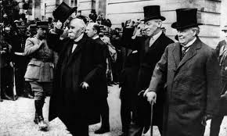
Part 1: Were the peace treaties of 1919-23 fair?
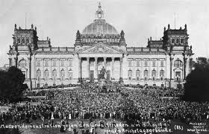

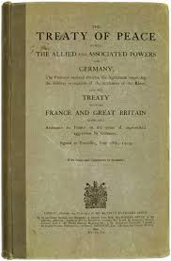
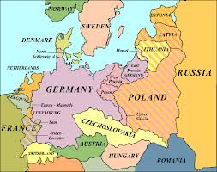
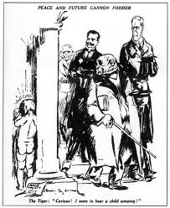
Overview
As soon as WW1 came to an end in November 1918, plans were made for a Peace Conference in Paris in 1919. They produced a number of treaties known collectively as the Versailles Settlement

Treaty | Date | Country affected
Versailles | June 1919 | Germany
Saint Germain | September 1919 | Austria
Neuilly | November 1919 | Bulgaria
Trianon | June 1920 | Hungary
Sevres | August 1920 | Turkey
Lausanne | June 1923 | Turkey

The treaties were made after much disagreement and compromise. They were immediately, and continue to be the focus of fierce criticism and debate.
The roles of individuals such as Wilson, Clemenceau and Lloyd George in the peace-making process
The Paris Peace Conference was attended by 32 states representing more than two-thirds of the world’s population. Soviet Russia was not invited and the defeated powers were allowed no say in negotiations. The main peace-makers were France, Italy, USA, Britain and Japan. Of these, ‘The Big Three’ dominated:

- George ‘Tiger’ Clemenceau, French Prime Minister, 1917-1920

His main aim was to ensure the security of France. He wanted to weaken Germany to prevent that nation being a threat to European peace again. He feared an attack from Germany because they shared a common border without a natural frontier such as a river. France had been invaded by Prussia (which later joined with other states to form Germany) in 1870 and by Germany in August 1914.

France had suffered 1.4m military and 300,000 civilian deaths in the war as well as great damage to the land including the destruction of bridges, railways, towns and villages by the retreating German army in 1918.

Clemenceau demanded:
- Disbanding most of Germany’s army, navy and air force
- Very high reparations
- The return of Alsace-Lorraine taken by Germany after the Franco-Prussian War
- Many German colonies to be handed to France
- The Rhineland to be made an independent state so France and Germany no longer shared a common border
- The Saar Basin to be transferred to France

- Woodrow Wilson, US President, 1913-1921

He was an idealist who wanted to make the ‘world safe for democracy’, based on his Fourteen Points. He had different motives to Clemenceau partly because:

- The US had not declared war before April 1917 and wasn’t fully involved until 1918
- The USA had relatively light casualties of 100,000 men and less than 800 civilians and no territorial damage
- The war had provided good business for US manufacturers, merchants and financiers

Lack of a national grievance meant Wilson could take a more detached view but hope to be the guiding spirit behind a ‘fair and lasting peace’ including:

- Open diplomacy and no secret treaties (as had caused WW1, in his view)
- Disarmament for all states to a level just enough to keep basic defence
- Self-determination, allowing national groups such as Slavs, Czechs and Poles to form independent states
- A general association, or League, of nations
- Settlement of colonial disputes taking the interests of colonial populations into account

- David Lloyd George, British Prime Minister, 1916-22

Before the Conference it looked like Britain shared the French desire for a harsh peace settlement to be imposed on Germany. This was because:

- Britain had suffered attacks on her mainland to Yorkshire coastal towns in 1914 and Zeppelin raids on London, Edinburgh and elsewhere, 1915-18
- 900,000 military and 100,000 civilian deaths
- Britain’s economy, especially exports, had been severely disrupted
- Britain was concerned about France’s eastern frontier which was effectively Britain’s outer defence
- The public demanded vengeance. Lloyd George promised this in the general election of November 1918, saying Germany should pay the full cost of war and Britain should be given many German colonies

However, by January 1919 Lloyd George had decided he wanted a more moderate peace because:

- He came to realise that the future economic well-being of Britain depended largely on the economic revival of Europe which in turn depended on the revival of Germany, previously Britain’s most important European customer
- If Germany was deprived of the Rhineland, where much of its industry was located, it wouldn’t be wealthy enough to buy British goods on the same scale as before
- High reparations would deprive Germany of money that could be invested
- A weak Germany would provide an inadequate barrier against the spread of communism
- A very harsh treaty would lead to intense grievance and attempts to overturn it

Lloyd George was able to exert some influence on Clemenceau. He persuaded Clemenceau to:

- Abandon the idea of an independent Rhineland
- Abandon the idea of naming a definite and very high figure for reparations
- Abandon the idea that the Saar Basin be transferred to France
- Abandon the idea that Danzig be handed to Poland

Lloyd George had also been motivated by wanting to stop France becoming too strong – Britain could remain a world power if the balance of power in Europe was maintained

The impact of the peace treaties on the defeated countries
In the end the main terms of the treaty were:
- War Guilt Clause (Article 231) – Germany and her allies had to accept total responsibility for starting the war
- Reparations – Germany had to accept liability for reparations with the amount to be decided later by a Reparations Commission (in 1921 a figure of £6,600m was set)
- German army restricted to 100,000 men, with no conscription
- No tanks, armoured vehicles or heavy artillery
- No military or naval air force allowed
- Navy restricted to six battleships, 12 destroyers, six light cruisers, 12 torpedo boats, no submarines
- The Rhineland to become a demilitarised zone with no German troops or fortifications. An Allied army of occupation on the west bank of the Rhine for 15 years
- Germany to lose all colonies in Africa and the Far East
- Alsace and Lorraine to be returned to France
- Eupen, Malmedy and Moresnet to be transferred to Belgium
- Northern Schleswig to be transferred to Denmark
- West Prussia, Posen and parts of Upper Silesia to be transferred to Poland
- Hultschin to be transferred to Czechoslovakia
- The Saar Basin to be administered by the League of Nations for 15 years. A plebiscite would then be held to decide its future. Profits of its coal mines were to go to France
- Memel was to be transferred to Lithuania
- Danzig was to be a Free City administered by the League of Nations Poland could use its port
- The Treaty of Brest-Litovsk imposed by Germany on Russia was cancelled. Estonia, Latvia and Lithuania were taken from Germany and established as independent states
- Union between Germany and Austria was forbidden
- Germany had to accept the Covenant of the League of Nations although she wasn’t allowed to join at first
German objections
Germany had numerous criticisms of the Versailles Treaty. Germany’s general objection was that it was too harsh. Many felt Germany was being punished twice over – they had to pay reparations, but were being deprived of the resources such as coal and iron ore needed to pay them. However, some would argue that this was fair as Germany had imposed the equally harsh treaty of Brest-Litovsk on Russia in March 1918.
Germany also objected that the war was a ‘Diktat’, or a dictated peace. German officials had been excluded from the negotiations and were simply handed a draft copy and invited to respond in writing. This led to some minor changes, such as holding a plebiscite in Upper Silesia. If the Germans had refused to sign the treaty the Allied naval blockade would have continued and the war would have restarted.
The Germans further felt that the War Guilt Clause rubbed salt in their wounds. They did not believe they and their allies were solely responsible for starting the war. It could be argued that the first military action in the immediate lead-up to the conflict had been the Russian mobilization of July 1914.

Political impact
On 28 June 1919 two representatives of the new Weimar German Government signed the treaty under duress. Although they had little option but to sign it, doing so made them instantly unpopular. It was a symbol of humiliation and dishonour that they had agreed to. The authority of the new republic was seriously undermined:

- Left-wing extremists groups exploited the unpopularity of the Weimar Government by promoting rebellions, such as that in the Ruhr in 1920
- Many members of the army were furious with the government for agreeing to the disarmament clauses, so joined the Freikorps, an unofficial, anti-communist vigilante group. When the government attempted to disband them in March 1923 Freikorps units commanded by Wolfgang Kapp staged a coup in Berlin and declared a new national government. The army refused to intervene and the government was on the point of collapse. It only survived because of a general strike which brought public services to a standstill
- Right-wing politicians and activists expressed their disapproval by supporting attempts to overthrow the government, such as the Munich Putsch of November 1923
- Right-wing extremists assassinated high-profile government ministers such as Walter Rathenau and Matthias Erzberger

Economic impact

The Germans claimed that in signing the treaty they were also signing a blank cheque since they had to agree to pay whatever reparations figure was eventually set. When the figure of £6,600m was set in 1921 Germany claimed it was more than they could afford to pay.

Major economic problems followed:

Germany paid the first instalment of £100m in 1921, but failed to pay in 1922. The French and Belgians decided to take direct action by invading and occupying the Ruhr, Germany’s most valuable industrial area, to seize coal and other resources to the value of the missed payments. Germany couldn’t offer armed resistance, but the government ordered passive resistance – German workers in the Ruhr went on strike. The French responded by expelling more than 100,000 Germans from the region and killing 130 who resisted.

The German government now needed to pay to re-house and feed the displaced population, but government income had declined due to the ending of Ruhr taxation receipts. To make up for lost revenue the government began to print money. This turned already high inflation into hyper-inflation. The German currency – the mark – became worthless and savings lost all real value. Eggs, cigarettes and bags of sugar began to be used as currency.

These problems were partially solved by Gustav Stresemann who became Chancellor in August 1923. He took the unpopular decision of ending passive resistance. He introduced a temporary new currency – the Rentenmark – with strictly controlled circulation, and he agreed to resume reparation payments. The Dawes Plan of 1924 introduced a more flexible payment schedule and the 1929 Young Plan reduced the outstanding amount to £2000m.

Disarmament

Germany objected about the disarmament clauses in particular because they claimed 100,000 soldiers was not enough for border defence and it would be difficult to deal with revolts and uprisings.

Wilson’s Fourteen Points

Germany always maintained that the armistice was signed on the understanding that the peace settlement would be based on Wilson’s Fourteen Points, so it was seen as a betrayal because:

- Reparations were not mentioned in the Fourteen Points
- Wilson had proposed disarmament and an assembly of nations, but only defeated powers were disarmed and Germany were not allowed to join the League of Nations.
- The Fourteen Points stressed self-determination, yet in the treaty this didn’t apply to Austria, Alsace-Lorraine or the Saar Basin (for 15 years)

Treaties with other countries

The treaties affecting Germany’s allies also all had:
- A war guilt clause
- An obligation to pay reparations
- Reduction in armaments
- Acceptance of the Covenant of the League of Nations

Further specific details included:

The Treaty of Saint Germain with Austria, 10 September 1919:

- The new Republic of Austria had to accept the break-up of the Austro-Hungarian Empire
- Austria had to recognise the independence of Hungary, Czechoslovakia, Yugoslavia and Poland
- Territory from the former Empire was transferred to Poland, Czechoslovakia, Yugoslavia, Italy and Romania
- Union between Austria and Germany was forbidden

In summary, Austria became a small, land-locked country surrounded by hostile states. Austria particularly resented the fact that union with Germany was forbidden and three million Sudeten Germans were placed under Czech rule – going against the principle of self-determination.

The Treaty of Trianon with Hungary, 4 June 1920

- Hungary to accept the break-up of the Austro-Hungarian Empire
- Hungary had to recognise the independence of Yugoslavia and Czechoslovakia
- Territory from the former Empire was transferred to Czechoslovakia, Yugoslavia and Romania

Hungary was dismayed by these terms. More than 70% of its territory and one-third of its population had been lost. Hungary was also deprived of its ports, becoming land-locked.

The Treaty of Neuilly with Bulgaria, 27 November 1919

- Bulgaria had to recognise the independence of Yugoslavia
- Bulgaria lost territory to Greece, Yugoslavia and Romania

Bulgarians regarded the treaty as a national catastrophe. It brought to an end the 40-year struggle for the unification of the Bulgarian-populated territories. With the loss of land and the blow to its national pride Bulgaria faced an uncertain future.

The Treaty of Sevres with Turkey, 10 August 1920

- Turkey had to recognise the independence of the Kingdom of Hejaz (which later became part of Saudi Arabia) and Armenia
- Turkey’s provinces in the Middle East were given to Britain and France
- Turkey lost territory to Greece and Italy
- The Dardanelles Strait became an international waterway

The plight of Turkey after WW1 sparked a nationalist movement led by Mustapha Kemal. He challenged the Treaty of Sevres by force, driving the Greeks out of Smyrna. This led to a renegotiated treaty:

The Treaty of Lausanne with Turkey, 24 July 1923

- Turkey confirmed the loss of its provinces in the Middle East
- Turkey received back most of its European territory
- The Dardanelles Strait was returned to Turkish sovereignty
- Restrictions on armed forces were removed
- Turkey was no longer to pay reparations

Contemporary opinions about the treaties
Opinions divided into three main categories:

- Those who thought the Versailles Settlement was too harsh
E.g.
‘The criminal madness of this peace will drain Germany’s national life-blood. It is a shameless blow in the face of common sense. It is inflicting the deepest wounds on us Germans as our world lies in wreckage about us.’
From a speech made by a member of the German Reichstag in 1919

‘It was a peace of revenge. It was full of injustice. It was incapable of fulfilment. It sowed the seeds from which new wars might spring. The wild impossibility of extracting those vast reparations from the defeated enemy ought to have been obvious to the most ignorant schoolboy’
From an article by a British journalist in 1922.

- Those who thought it wasn’t harsh enough
E.g.
‘This is not a peace treaty, it is an armistice for twenty years.’
Frenchman Marshal Foch at the signing of the Treaty, 1919

‘Germany is supposedly going to undertake to have neither troops nor fortresses on the left bank and with a zone extending 50 kilometres east of the Rhine. But the Treaty does not provide for any permanent supervision of troops and armaments on the left bank any more than elsewhere in Germany … We can thus have no guarantee that after … fifteen years and the evacuation of the left bank, the Germans will not filter troops by degrees into this district.’
President Raymond Poincare to the Paris Peace Conference, 1919

- Those who thought it was fair
E.g.
‘ … empires cannot be shattered and new states raised upon their ruins without disturbance. To create new boundaries is always to create new troubles … While I should have preferred a different peace, I doubt whether it could have been made.’
Edward M House, a US diplomat, June 1919

‘Do not think of this treaty … as merely a settlement with Germany, but there is not anything in it that she did not earn. Indeed, she earned more than she can ever be able to pay for, and the punishment exacted of her is not a punishment greater than she can bear, and it is absolutely necessary in order that no other nation may ever plot such a thing against humanity and civilization.’
President Woodrow Wilson to the League of Nations, September 1919.

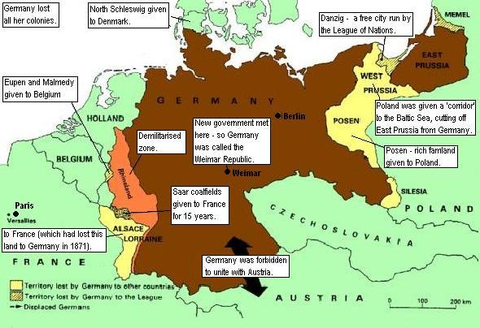

Websites:

The National Archives
www.nationalarchives.gov.uk/cabinetpapers/themes/post-war-peace-treaties.htm
History Learning Site
www.historylearningsite.co.uk/treaty_of_versailles.htm
firstworldwar.com
www.firstworldwar.com/source/versailles.htm
Spartacus Educational
www.spartacus.schoolnet.co.uk/FWWversailles.htm
The Avalon Project
http://avalon.law.yale.edu/subject_menus/versailles_menu.asp
BBC History
www.bbc.co.uk/schools/worldwarone/hq/outcomes3_01.shtml
History
www.history.co.uk/explore-history/ww2/treaty-of-versailles.htm

